bamazonCustomer.js

1. When the file is executed, the app displays everything that’s available at the store: product ID; product name; product department; product price; and product quantity. These data are pulled from a table called “products” in MySql.

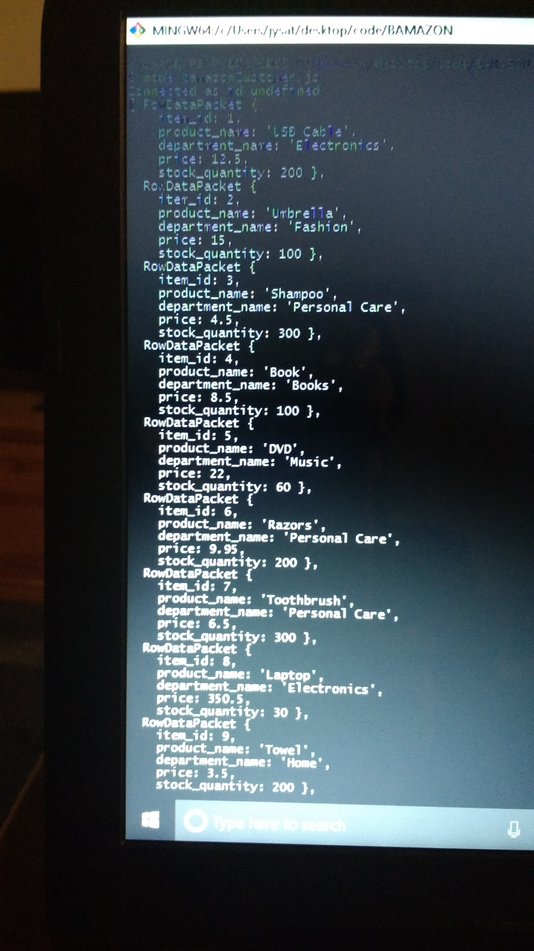

1. The user is asked which product ID they are interested in. In this case, ID #10.
2. The user is asked how many units of that product they want. In this case 1.
3. The total price is displayed. In this case, the user wants one box of cat litter, so the total is $18.75.

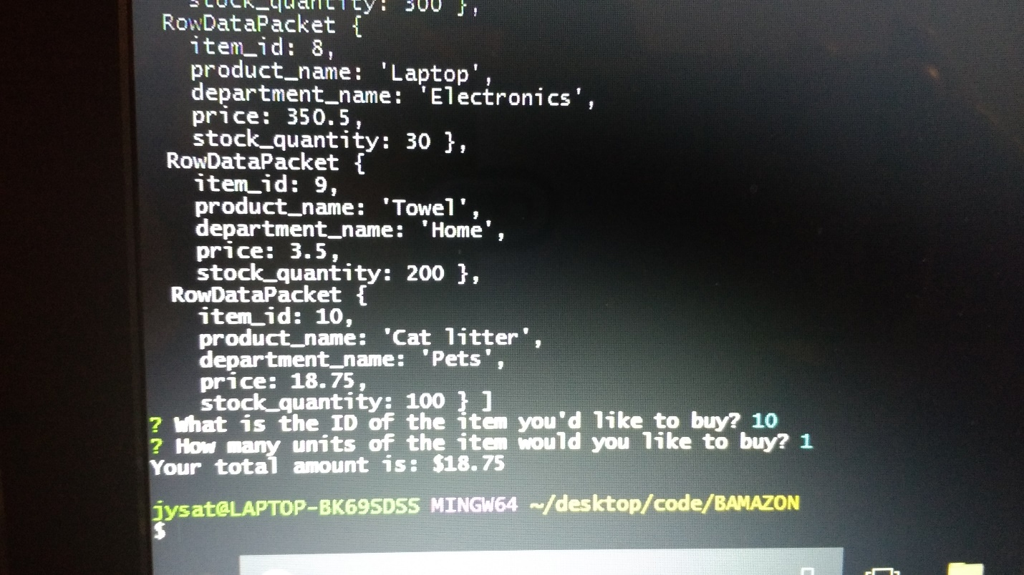

1. The inventory gets updated in MySql. In this case, the quantity of cat litter decreased from 100 to 99.

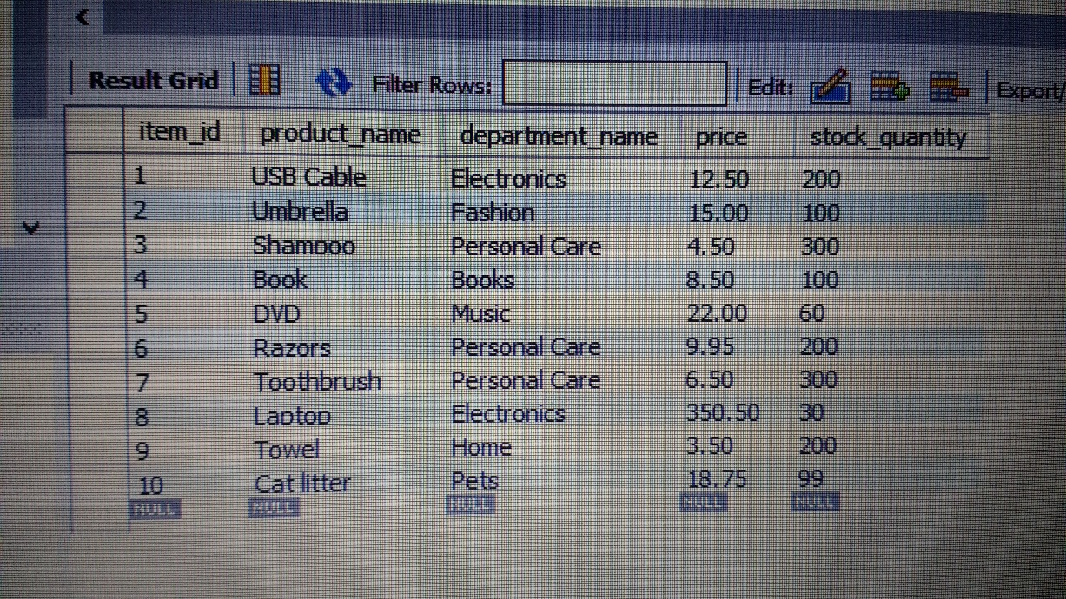

bamazonManager.js

1. The user is asked to select what they would like to do: View products for sale; View low inventory; Add to inventory; and Add new product.

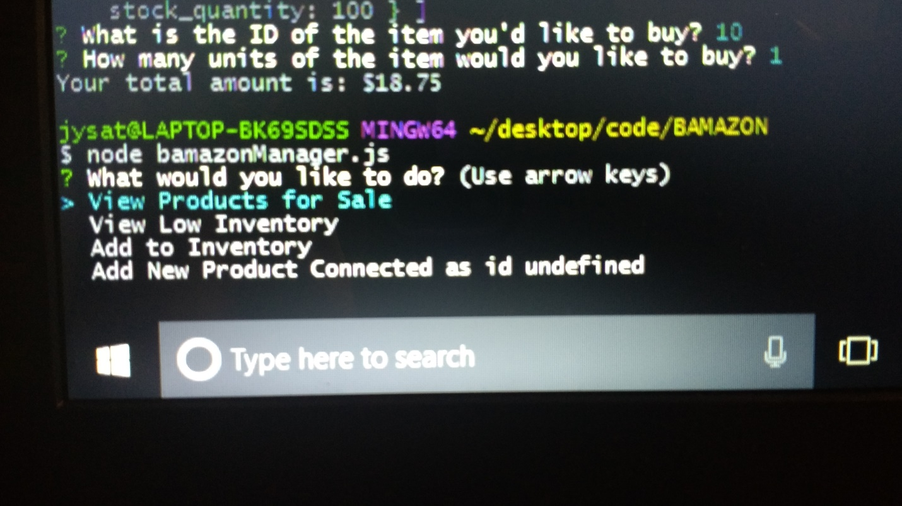

1. If they select “View products for sale,” the app displays everything that’s available at the store: product ID; product name; product department; product price; and product quantity. These data are pulled from a table called “products” in MySql.

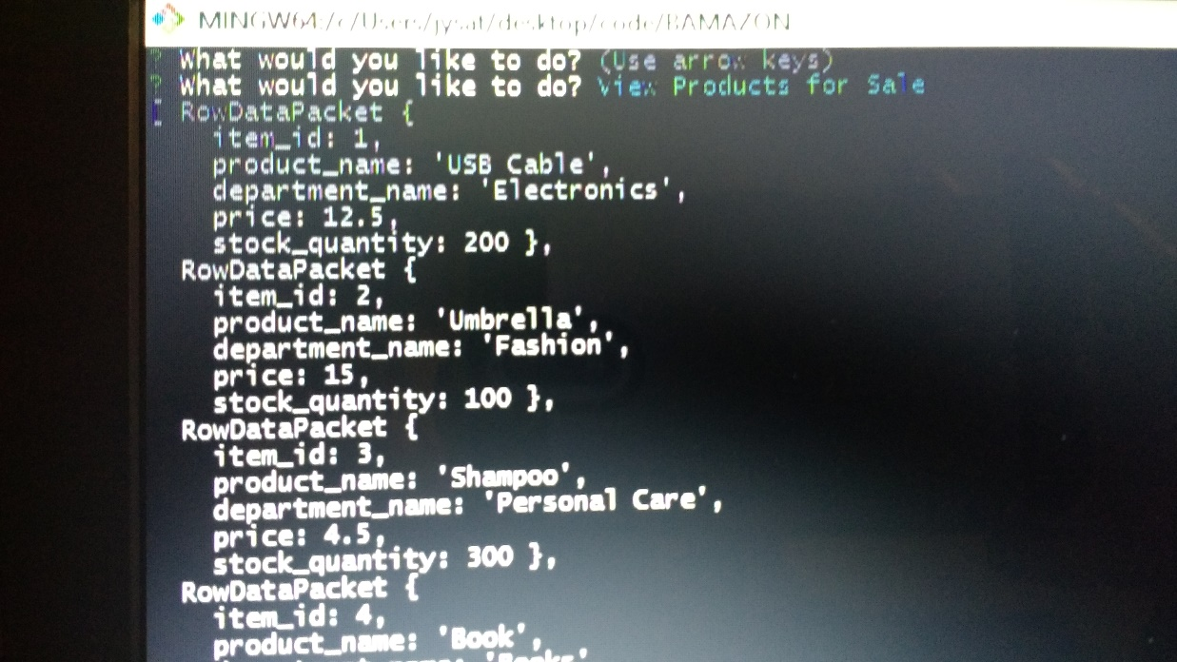

1. If they select “View low inventory,” the app displays all products with quantity of less than 100(this number is used for testing).

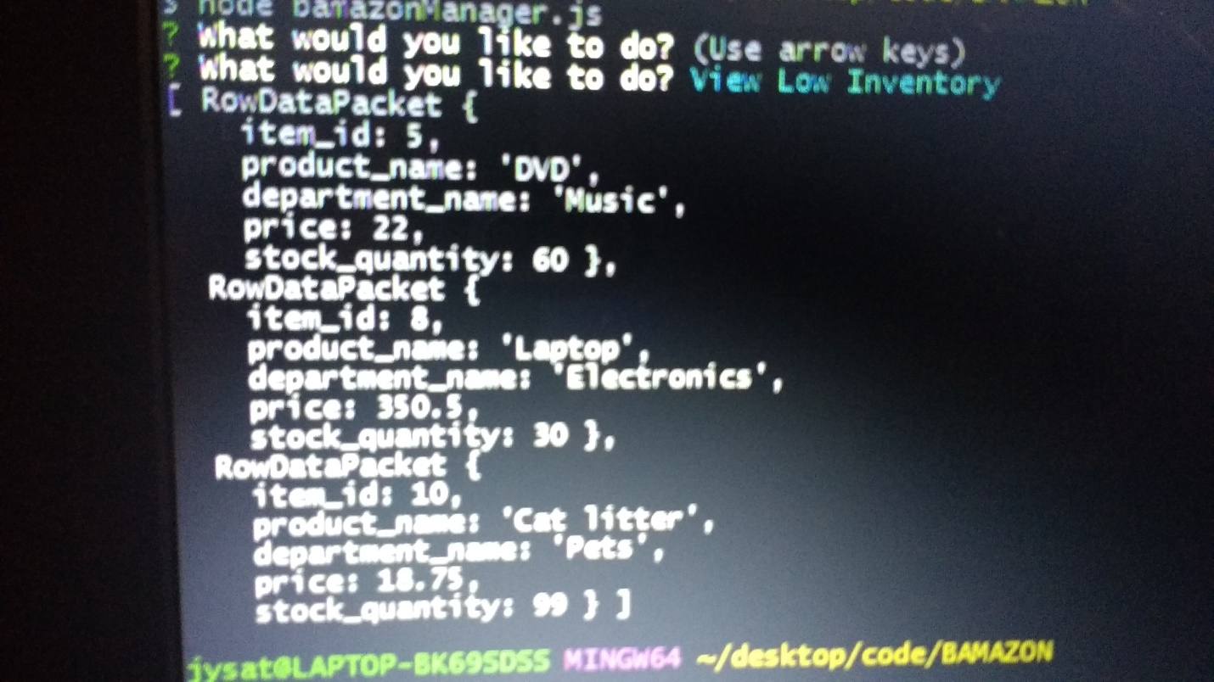

1. If they select “Add to inventory,” the app displays the product with quantity of less than 100(this number is used for testing). Then they’re asked which product ID whose quantity they wish to increase. Then they’re asked how many more units they wish to add.

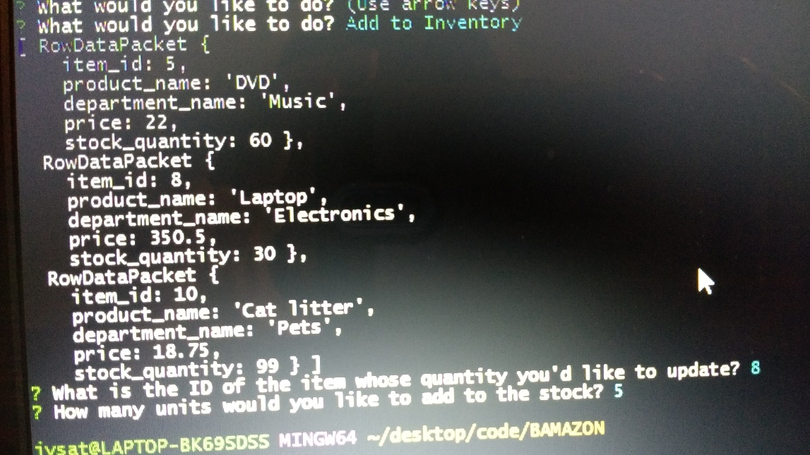

1. The table in MySql gets updated accordingly. In this case, the quantity of laptops increased from 30 to 35.

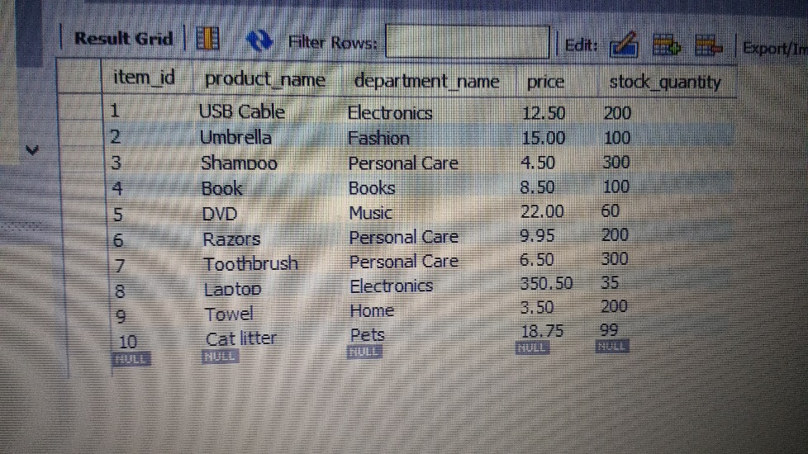

1. If they select “Add new product,” they are asked to put the new product name, product department, product price and quantity.

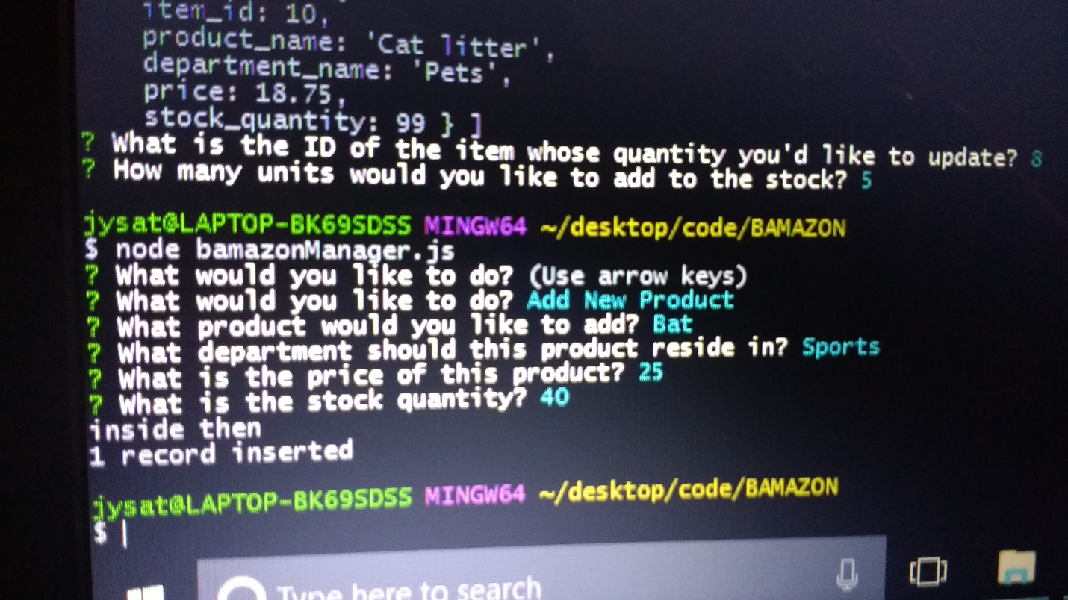

1. The new product gets inserted into the table in MySql accordingly. In this case, 40 bats are inserted as product ID #11, in the Sports department, at $25 each.

